**AnalogReadSerial**

程式碼截圖:

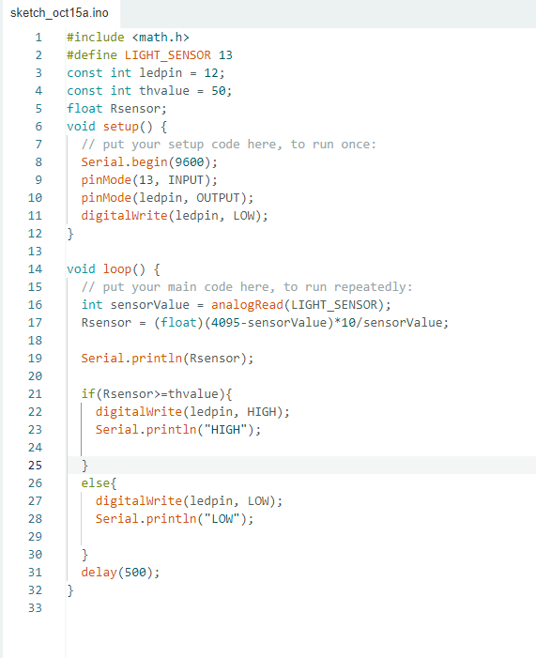

程式碼:

**Code**

#include <math.h>

#define LIGHT_SENSOR 13

const int ledpin = 12;

const int thvalue = 50;

float Rsensor;

void setup() {

  // put your setup code here, to run once:

  Serial.begin(9600);

  pinMode(13, INPUT);

  pinMode(ledpin, OUTPUT);

  digitalWrite(ledpin, LOW);

}

void loop() {

  // put your main code here, to run repeatedly:

  int sensorValue = analogRead(LIGHT_SENSOR);

  Rsensor = (float)(4095-sensorValue)*10/sensorValue;

  Serial.println(Rsensor);

  if(Rsensor>=thvalue){

    digitalWrite(ledpin, HIGH);

    Serial.println("HIGH");

  }

  else{

    digitalWrite(ledpin, LOW);

    Serial.println("LOW");

  }

  delay(500);

}

執行結果:

[物聯網介面-光感測器LED控制](https://youtube.com/shorts/02A9YCsIjts)